Software Testing Overview

Software Testing is evaluation of the software against requirements gathered from users and system specifications. Testing is conducted at the phase level in software development life cycle or at module level in program code. Software testing comprises of Validation and Verification.

Software Validation
Validation is process of examining whether or not the software satisfies the user requirements. It is carried out at the end of the SDLC. If the software matches requirements for which it was made, it is validated.
- Validation ensures the product under development is as per the user requirements.
- Validation answers the question – "Are we developing the product which attempts all that user needs from this software ?".
- Validation emphasizes on user requirements.

Software Verification
Verification is the process of confirming if the software is meeting the business requirements, and is developed adhering to the proper specifications and methodologies.
- Verification ensures the product being developed is according to design specifications.
- Verification answers the question– "Are we developing this product by firmly following all design specifications ?"
- Verifications concentrates on the design and system specifications.
Target of the test are -
- Errors - These are actual coding mistakes made by developers. In addition, there is a difference in output of software and desired output, is considered as an error.
- Fault - When error exists fault occurs. A fault, also known as a bug, is a result of an error which can cause system to fail.
- Failure - failure is said to be the inability of the system to perform the desired task. Failure occurs when fault exists in the system.

Manual Vs Automated Testing
Testing can either be done manually or using an automated testing tool:
- Manual - This testing is performed without taking help of automated testing tools. The software tester prepares test cases for different sections and levels of the code, executes the tests and reports the result to the manager.
Manual testing is time and resource consuming. The tester needs to confirm whether or not right test cases are used. Major portion of testing involves manual testing.
- Automated This testing is a testing procedure done with aid of automated testing tools. The limitations with manual testing can be overcome using automated test tools.
A test needs to check if a webpage can be opened in Internet Explorer. This can be easily done with manual testing. But to check if the web-server can take the load of 1 million users, it is quite impossible to test manually.
There are software and hardware tools which helps tester in conducting load testing, stress testing, regression testing.

Testing Approaches
Tests can be conducted based on two approaches –
- Functionality testing
- Implementation testing
When functionality is being tested without taking the actual implementation in concern it is known as black-box testing. The other side is known as white-box testing where not only functionality is tested but the way it is implemented is also analyzed.
Exhaustive tests are the best-desired method for a perfect testing. Every single possible value in the range of the input and output values is tested. It is not possible to test each and every value in real world scenario if the range of values is large.

Black-box testing
It is carried out to test functionality of the program. It is also called ‘Behavioral’ testing. The tester in this case, has a set of input values and respective desired results. On providing input, if the output matches with the desired results, the program is tested ‘ok’, and problematic otherwise.
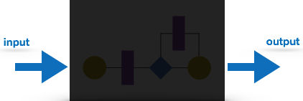
In this testing method, the design and structure of the code are not known to the tester, and testing engineers and end users conduct this test on the software.
Black-box testing techniques:
- Equivalence class - The input is divided into similar classes. If one element of a class passes the test, it is assumed that all the class is passed.
- Boundary values - The input is divided into higher and lower end values. If these values pass the test, it is assumed that all values in between may pass too.
- Cause-effect graphing - In both previous methods, only one input value at a time is tested. Cause (input) – Effect (output) is a testing technique where combinations of input values are tested in a systematic way.
- Pair-wise Testing - The behavior of software depends on multiple parameters. In pairwise testing, the multiple parameters are tested pair-wise for their different values.
- State-based testing - The system changes state on provision of input. These systems are tested based on their states and input.

White-box testing
It is conducted to test program and its implementation, in order to improve code efficiency or structure. It is also known as ‘Structural’ testing.
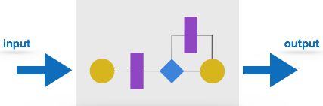
In this testing method, the design and structure of the code are known to the tester. Programmers of the code conduct this test on the code.
The below are some White-box testing techniques:
- Control-flow testing - The purpose of the control-flow testing to set up test cases which covers all statements and branch conditions. The branch conditions are tested for both being true and false, so that all statements can be covered.
- Data-flow testing - This testing technique emphasis to cover all the data variables included in the program. It tests where the variables were declared and defined and where they were used or changed.

Testing Levels
Testing itself may be defined at various levels of SDLC. The testing process runs parallel to software development. Before jumping on the next stage, a stage is tested, validated and verified.
Testing separately is done just to make sure that there are no hidden bugs or issues left in the software. Software is tested on various levels -

Unit Testing
While coding, the programmer performs some tests on that unit of program to know if it is error free. Testing is performed under white-box testing approach. Unit testing helps developers decide that individual units of the program are working as per requirement and are error free.

Integration Testing
Even if the units of software are working fine individually, there is a need to find out if the units if integrated together would also work without errors. For example, argument passing and data updation etc.

System Testing
The software is compiled as product and then it is tested as a whole. This can be accomplished using one or more of the following tests:
- Functionality testing - Tests all functionalities of the software against the requirement.
- Performance testing - This test proves how efficient the software is. It tests the effectiveness and average time taken by the software to do desired task. Performance testing is done by means of load testing and stress testing where the software is put under high user and data load under various environment conditions.
- Security & Portability - These tests are done when the software is meant to work on various platforms and accessed by number of persons.

Acceptance Testing
When the software is ready to hand over to the customer it has to go through last phase of testing where it is tested for user-interaction and response. This is important because even if the software matches all user requirements and if user does not like the way it appears or works, it may be rejected.
- Alpha testing - The team of developer themselves perform alpha testing by using the system as if it is being used in work environment. They try to find out how user would react to some action in software and how the system should respond to inputs.
- Beta testing - After the software is tested internally, it is handed over to the users to use it under their production environment only for testing purpose. This is not as yet the delivered product. Developers expect that users at this stage will bring minute problems, which were skipped to attend.

Regression Testing
Whenever a software product is updated with new code, feature or functionality, it is tested thoroughly to detect if there is any negative impact of the added code. This is known as regression testing.

Testing Documentation
Testing documents are prepared at different stages -

Before Testing
Testing starts with test cases generation. Following documents are needed for reference –
- SRS document - Functional Requirements document
- Test Policy document - This describes how far testing should take place before releasing the product.
- Test Strategy document - This mentions detail aspects of test team, responsibility matrix and rights/responsibility of test manager and test engineer.
- Traceability Matrix document - This is SDLC document, which is related to requirement gathering process. As new requirements come, they are added to this matrix. These matrices help testers know the source of requirement. They can be traced forward and backward.

While Being Tested
The following documents may be required while testing is started and is being done:
- Test Case document - This document contains list of tests required to be conducted. It includes Unit test plan, Integration test plan, System test plan and Acceptance test plan.
- Test description - This document is a detailed description of all test cases and procedures to execute them.
- Test case report - This document contains test case report as a result of the test.
- Test logs - This document contains test logs for every test case report.

After Testing
The following documents may be generated after testing :
- Test summary - This test summary is collective analysis of all test reports and logs. It summarizes and concludes if the software is ready to be launched. The software is released under version control system if it is ready to launch.

Testing vs. Quality Control, Quality Assurance and Audit
We need to understand that software testing is different from software quality assurance, software quality control and software auditing.
- Software quality assurance - These are software development process monitoring means, by which it is assured that all the measures are taken as per the standards of organization. This monitoring is done to make sure that proper software development methods were followed.
- Software quality control - This is a system to maintain the quality of software product. It may include functional and non-functional aspects of software product, which enhance the goodwill of the organization. This system makes sure that the customer is receiving quality product for their requirement and the product certified as ‘fit for use’.
- Software audit - This is a review of procedure used by the organization to develop the software. A team of auditors, independent of development team examines the software process, procedure, requirements and other aspects of SDLC. The purpose of software audit is to check that software and its development process, both conform standards, rules and regulations.

Software Testing Tutorial

Software testing tutorial provides basic and advanced concepts of software testing. Our software testing tutorial is designed for beginners and professionals.
Software testing is widely used technology because it is compulsory to test each and every software before deployment.
Our Software testing tutorial includes all topics of Software testing such as Methods such as Black Box Testing, White Box Testing, Visual Box Testing and Gray Box Testing. Levels such as Unit Testing, Integration Testing, Regression Testing, Functional Testing. System Testing, Acceptance Testing, Alpha Testing, Beta Testing, Non-Functional testing, Security Testing, Portability Testing.

What is Software Testing
Software testing is a process of identifying the correctness of software by considering its all attributes (Reliability, Scalability, Portability, Re-usability, Usability) and evaluating the execution of software components to find the software bugs or errors or defects.
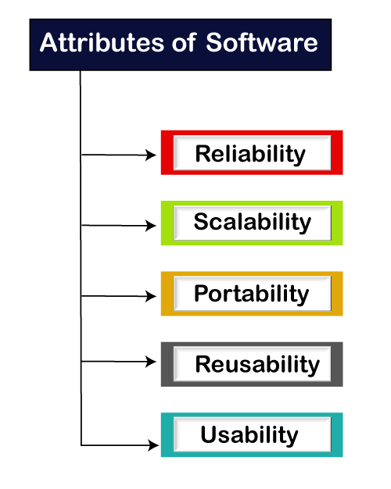
Software testing provides an independent view and objective of the software and gives surety of fitness of the software. It involves testing of all components under the required services to confirm that whether it is satisfying the specified requirements or not. The process is also providing the client with information about the quality of the software.
Testing is mandatory because it will be a dangerous situation if the software fails any of time due to lack of testing. So, without testing software cannot be deployed to the end user.

What is Testing
Testing is a group of techniques to determine the correctness of the application under the predefined script but, testing cannot find all the defect of application. The main intent of testing is to detect failures of the application so that failures can be discovered and corrected. It does not demonstrate that a product functions properly under all conditions but only that it is not working in some specific conditions.
Testing furnishes comparison that compares the behavior and state of software against mechanisms because the problem can be recognized by the mechanism. The mechanism may include past versions of the same specified product, comparable products, and interfaces of expected purpose, relevant standards, or other criteria but not limited up to these.
Testing includes an examination of code and also the execution of code in various environments, conditions as well as all the examining aspects of the code. In the current scenario of software development, a testing team may be separate from the development team so that Information derived from testing can be used to correct the process of software development.
The success of software depends upon acceptance of its targeted audience, easy graphical user interface, strong functionality load test, etc. For example, the audience of banking is totally different from the audience of a video game. Therefore, when an organization develops a software product, it can assess whether the software product will be beneficial to its purchasers and other audience.

Type of Software testing
We have various types of testing available in the market, which are used to test the application or the software.
With the help of below image, we can easily understand the type of software testing:
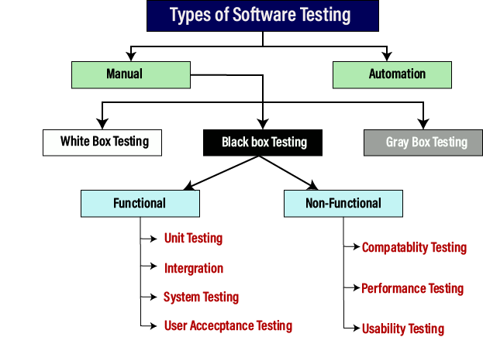

Manual testing
The process of checking the functionality of an application as per the customer needs without taking any help of automation tools is known as manual testing. While performing the manual testing on any application, we do not need any specific knowledge of any testing tool, rather than have a proper understanding of the product so we can easily prepare the test document.
Manual testing can be further divided into three types of testing, which are as follows:
- White box testing
- Black box testing
- Gray box testing
For more information about manual testing, refers to the below link:
https://www.javatpoint.com/manual-testing

Automation testing
Automation testing is a process of converting any manual test cases into the test scripts with the help of automation tools, or any programming language is known as automation testing. With the help of automation testing, we can enhance the speed of our test execution because here, we do not require any human efforts. We need to write a test script and execute those scripts.
For more information about manual testing, refers to the below link:
https://www.javatpoint.com/automation-testing

Prerequisite
Before learning software testing, you should have basic knowledge of basic computer functionality, basic mathematics, computer language, and logical operators.

Audience
Our software testing tutorial is designed for beginners and professionals.

Problems
We assure that you will not find any problem in this Software Testing Tutorial. But if there is any mistake, please post the problem in contact form.

Software Testing Principles
Software testing is a procedure of implementing software or the application to identify the defects or bugs. For testing an application or software, we need to follow some principles to make our product defects free, and that also helps the test engineers to test the software with their effort and time. Here, in this section, we are going to learn about the seven essential principles of software testing.
Let us see the seven different testing principles, one by one:
- Testing shows the presence of defects
- Exhaustive Testing is not possible
- Early Testing
- Defect Clustering
- Pesticide Paradox
- Testing is context-dependent
- Absence of errors fallacy
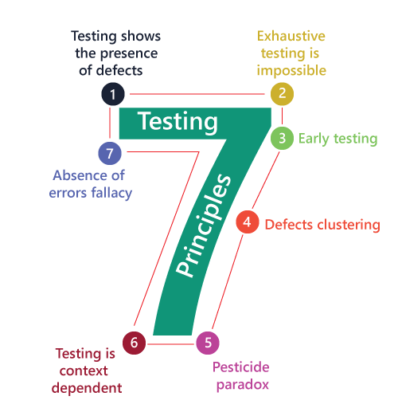

Testing shows the presence of defects
The test engineer will test the application to make sure that the application is bug or defects free. While doing testing, we can only identify that the application or software has any errors. The primary purpose of doing testing is to identify the numbers of unknown bugs with the help of various methods and testing techniques because the entire test should be traceable to the customer requirement, which means that to find any defects that might cause the product failure to meet the client's needs.
By doing testing on any application, we can decrease the number of bugs, which does not mean that the application is defect-free because sometimes the software seems to be bug-free while performing multiple types of testing on it. But at the time of deployment in the production server, if the end-user encounters those bugs which are not found in the testing process.

Exhaustive Testing is not possible
Sometimes it seems to be very hard to test all the modules and their features with effective and non- effective combinations of the inputs data throughout the actual testing process.
Hence, instead of performing the exhaustive testing as it takes boundless determinations and most of the hard work is unsuccessful. So we can complete this type of variations according to the importance of the modules because the product timelines will not permit us to perform such type of testing scenarios.

Early Testing
Here early testing means that all the testing activities should start in the early stages of the software development life cycle's requirement analysis stage to identify the defects because if we find the bugs at an early stage, it will be fixed in the initial stage itself, which may cost us very less as compared to those which are identified in the future phase of the testing process.
To perform testing, we will require the requirement specification documents; therefore, if the requirements are defined incorrectly, then it can be fixed directly rather than fixing them in another stage, which could be the development phase.

Defect clustering
The defect clustering defined that throughout the testing process, we can detect the numbers of bugs which are correlated to a small number of modules. We have various reasons for this, such as the modules could be complicated; the coding part may be complex, and so on.
These types of software or the application will follow the Pareto Principle, which states that we can identify that approx. Eighty percent of the complication is present in 20 percent of the modules. With the help of this, we can find the uncertain modules, but this method has its difficulties if the same tests are performing regularly, hence the same test will not able to identify the new defects.

Pesticide paradox
This principle defined that if we are executing the same set of test cases again and again over a particular time, then these kinds of the test will not be able to find the new bugs in the software or the application. To get over these pesticide paradoxes, it is very significant to review all the test cases frequently. And the new and different tests are necessary to be written for the implementation of multiple parts of the application or the software, which helps us to find more bugs.

Testing is context-dependent
Testing is a context-dependent principle states that we have multiple fields such as e-commerce websites, commercial websites, and so on are available in the market. There is a definite way to test the commercial site as well as the e-commerce websites because every application has its own needs, features, and functionality. To check this type of application, we will take the help of various kinds of testing, different technique, approaches, and multiple methods. Therefore, the testing depends on the context of the application.

Absence of errors fallacy
Once the application is completely tested and there are no bugs identified before the release, so we can say that the application is 99 percent bug-free. But there is the chance when the application is tested beside the incorrect requirements, identified the flaws, and fixed them on a given period would not help as testing is done on the wrong specification, which does not apply to the client's requirements. The absence of error fallacy means identifying and fixing the bugs would not help if the application is impractical and not able to accomplish the client's requirements and needs.

Types of Software Testing
• Read
• Courses

Testing is the process of executing a program to find errors. To make our software perform well it should be error-free. If testing is done successfully it will remove all the errors from the software. In this article, we will discuss first the principles of testing and then we will discuss, the different types of testing.

Principles of Testing
- All the tests should meet the customer’s requirements.
- To make our software testing should be performed by a third party.
- Exhaustive testing is not possible. As we need the optimal amount of testing based on the risk assessment of the application.
- All the tests to be conducted should be planned before implementing it
- It follows the Pareto rule(80/20 rule) which states that 80% of errors come from 20% of program components.
- Start testing with small parts and extend it to large parts.
- Types of Testing
There are basically 10 types of Testing.
- Unit Testing
- Integration Testing
- System Testing
- Functional Testing
- Acceptance Testing
- Smoke Testing
- Regression Testing
- Performance Testing
- Security Testing
- User Acceptance Testing
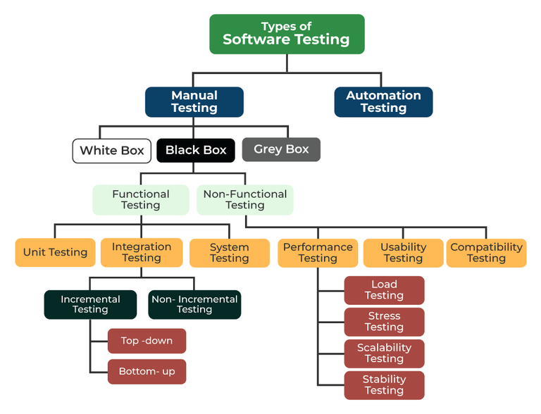
Types of Software Testing

Unit Testing
Unit testing is a method of testing individual units or components of a software application. It is typically done by developers and is used to ensure that the individual units of the software are working as intended. Unit tests are usually automated and are designed to test specific parts of the code, such as a particular function or method. Unit testing is done at the lowest level of the software development process, where individual units of code are tested in isolation.
Advantages of Unit Testing: Some of the advantages of Unit Testing are listed below.
- It helps to identify bugs early in the development process before they become more difficult and expensive to fix.
- It helps to ensure that changes to the code do not introduce new bugs.
- It makes the code more modular and easier to understand and maintain.
- It helps to improve the overall quality and reliability of the software.
Note: Some popular frameworks and tools that are used for unit testing include JUnit, NUnit, and xUnit.
It’s important to keep in mind that Unit Testing is only one aspect of software testing and it should be used in combination with other types of testing such as integration testing, functional testing, and acceptance testing to ensure that the software meets the needs of its users.
It focuses on the smallest unit of software design. In this, we test an individual unit or group of interrelated units. It is often done by the programmer by using sample input and observing its corresponding outputs.
Example:
a) In a program we are checking if the loop, method, or function is working fine.
b) Misunderstood or incorrect, arithmetic precedence.
c) Incorrect initialization.

Integration Testing
Integration testing is a method of testing how different units or components of a software application interact with each other. It is used to identify and resolve any issues that may arise when different units of the software are combined. Integration testing is typically done after unit testing and before functional testing and is used to verify that the different units of the software work together as intended.
Different Ways of Performing Integration Testing: There are different ways of Integration Testing that are discussed below.
- Top-down integration testing: It starts with the highest-level modules and differentiates them from lower-level modules.
- Bottom-up integration testing: It starts with the lowest-level modules and integrates them with higher-level modules.
- Big-Bang integration testing: It combines all the modules and integrates them all at once.
- Incremental integration testing: It integrates the modules in small groups, testing each group as it is added.

Advantages of Integrating Testing
- It helps to identify and resolve issues that may arise when different units of the software are combined.
- It helps to ensure that the different units of the software work together as intended.
- It helps to improve the overall reliability and stability of the software.
- It’s important to keep in mind that Integration testing is essential for complex systems where different components are integrated together.
- As with unit testing, integration testing is only one aspect of software testing and it should be used in combination with other types of testing such as unit testing, functional testing, and acceptance testing to ensure that the software meets the needs of its users.
The objective is to take unit-tested components and build a program structure that has been dictated by design. Integration testing is testing in which a group of components is combined to produce output.
Integration testing is of four types: (i) Top-down (ii) Bottom-up (iii) Sandwich (iv) Big-Bang
Example:
(a) Black Box testing:- It is used for validation. In this, we ignore internal working mechanisms and focus on what is the output?.
(b) White box testing:- It is used for verification. In this, we focus on internal mechanisms i.e. how the output is achieved?.

Regression Testing
Regression testing is a method of testing that is used to ensure that changes made to the software do not introduce new bugs or cause existing functionality to break. It is typically done after changes have been made to the code, such as bug fixes or new features, and is used to verify that the software still works as intended.
Regression testing can be performed in different ways, such as:
- Retesting: This involves testing the entire application or specific functionality that was affected by the changes.
- Re–execution: This involves running a previously executed test suite to ensure that the changes did not break any existing functionality.
- Comparison: This involves comparing the current version of the software with a previous version to ensure that the changes did not break any existing functionality.

Advantages of Regression Testing
- It helps to ensure that changes made to the software do not introduce new bugs or cause existing functionality to break.
- It helps to ensure that the software continues to work as intended after changes have been made.
- It helps to improve the overall reliability and stability of the software.
- It’s important to keep in mind that regression testing is an ongoing process that should be done throughout the software development
- lifecycle to ensure that the software continues to work as intended. It should be automated as much as possible to save time and resources. Additionally, it’s important to have a well-defined regression test suite that covers
Every time a new module is added leads to changes in the program. This type of testing makes sure that the whole component works properly even after adding components to the complete program.
Example
In school records, suppose we have module staff, students, and finance combining these modules
and checking if the integration of these modules works fine in regression testing.

Smoke Testing
Smoke Testing is done to make sure that the software under testing is ready or stable for further testing
It is called a smoke test as the testing of an initial pass is done to check if it did not catch fire or smoke in the initial switch-on.
Example:
If the project has 2 modules so before going to the module make sure that module 1 works properly.

Alpha Testing
Alpha testing is a type of validation testing. It is a type of acceptance testing that is done before the product is released to customers. It is typically done by QA people.
Example:
When software testing is performed internally within the organisation.

Beta Testing
The beta test is conducted at one or more customer sites by the end-user of the software. This version is released for a limited number of users for testing in a real-time environment.
Example:
When software testing is performed for the limited number of people.

System Testing
System Testing is carried out on the whole system in the context of either system requirement specifications or functional requirement specifications or in the context of both. The software is tested such that it works fine for the different operating systems. It is covered under the black box testing technique. In this, we just focus on the required input and output without focusing on internal work. In this, we have security testing, recovery testing, stress testing, and performance testing.
Example:
This includes functional as well as nonfunctional testing.

Stress Testing
In Stress Testing, we give unfavorable conditions to the system and check how they perform in those conditions.
Example:
i. Test cases that require maximum memory or other resources are executed.
ii. Test cases that may cause thrashing in a virtual operating system.
ii. Test cases that may cause excessive disk requirement Performance Testing.
It is designed to test the run-time performance of software within the context of an integrated system. It is used to test the speed and effectiveness of the program. It is also called load testing. In it, we check, what is the performance of the system in the given load.
Example:
Checking several processor cycles.

Object-Oriented Testing
Object-Oriented Testing testing is a combination of various testing techniques that help to verify and validate object-oriented software. This testing is done in the following manner:
- Testing of Requirements,
- Design and Analysis of Testing,
- Testing of Code,
- Integration testing,
- System testing,
- User Testing.

Acceptance Testing
Acceptance testing is done by the customers to check whether the delivered products perform the desired tasks or not, as stated in the requirements. We use Object-Oriented Testing for discussing test plans and for executing the projects.

Advantages of Software Testing
- Improved software quality and reliability.
- Early identification and fixing of defects.
- Improved customer satisfaction.
- Increased stakeholder confidence.
- Reduced maintenance costs.

Disadvantages of Software Testing
- Time-Consuming and adds to the project cost.
- This can slow down the development process.
- Not all defects can be found.
- Can be difficult to fully test complex systems.
- Potential for human error during the testing process

